Seven Necessary Business Analyst Skills

* **Interpersonal/ Communication Skills**  
  By nature of the job, business analysts spend a great deal of time interacting with users, clients, management and developers. A project’s success may depend upon the business analyst clearly communicating details like project requirements, requested changes and testing results. Fluent language skills and written communication abilities are necessary to thrive in a [business analyst career](https://www.villanovau.com/resources/business-analysis/business-analyst-career/).
* **Technical Skills**  
  In order to identify business solutions, a business analyst should know what information technology applications are being utilized, what new possible outcomes can be achieved through current platforms and what the latest technology offers. Testing software and designing business systems are also important technical business analyst skills. Gaining respect and creating a sense of confidence among IT and business end-users requires a business analyst to speak with confidence about business and technology, and to demonstrate a strong technical aptitude.
* **Analytical Skills**  
  A business analyst’s skill set should include outstanding analytical skills so that a customer’s business needs are properly interpreted and translated into application and [operational requirements](https://www.villanovau.com/resources/project-management/requirements-management/). One aspect of the job is analyzing data, documents, user input surveys and workflow to determine which course of action will correct the business problem. Strong analytical skills are beneficial in performing the business analyst’s job successfully.
* **Problem Solving Skills**  
  While the ability to create workable solutions to business problems is not unique to business analysts, it is a necessary skill for performing the job successfully. As with most IT roles, the business analyst’s career may be spent dealing with frequent and random changes. When these professionals are working to developing custom business solutions, nothing is 100% predictable – so finding ways to quickly resolve problems and move toward a project’s successful completion is important in the business analyst’s role.
* **Decision-Making Skills**  
  Another important business analyst skill is the ability to make decisions. As a consultant to management and advisor to developers, the business analyst is called upon for sound judgment in a wide variety of business matters, any number of which could determine the viability of the business. Professionals who wish to pursue a business analyst career should be able to assess a situation, receive input from stakeholders, and select a course of action.
* **Managerial Skills**  
  Another skill a business analyst should possess is the ability to manage projects. Planning the project scope, directing staff members, handling change requests, forecasting budgets and keeping everyone on the project within allotted time constraints are just some of the management skills a business analyst should possess. Supervising projects of all sizes, from inception to implementation – and usually concurrently – can take a high degree of managerial skill.
* **Negotiation and Persuasion Skills**  
  A business analyst serves as a liaison between developers and users, clients and companies, and management and IT. Finding the balance between individual wants and business needs, and then interacting with a variety of personality types toward a solution that works for the business, takes professional persuasion skills. When competing for client projects, a business analyst’s negotiation skills come into frequent use, with the goal of achieving a profitable outcome for the company and a working solution for the client. Maintaining relationships within an organization and with external partners is an important function of a business analyst that require strong negotiation and persuasion skills.

# [**6 knowledge Areas Business Analyst should know it well**](http://businessborderlines.com/business-analyst-knowledge-areas/)

Business Analysis is all about tasks and techniques followed to qualify the business needs and finding the business solution. The solution may include the system development, process development or improvement and change in the organizational structure. It is about the process to complete the tasks with quality and those who follow these processes are known as business analysts. In some organizations, these business analysts are referred as system analysts, business process analysts, business system analysts and much more.

The tasks followed by business analyst require specific knowledge areas and a business analyst should focus on them while performing the activities.

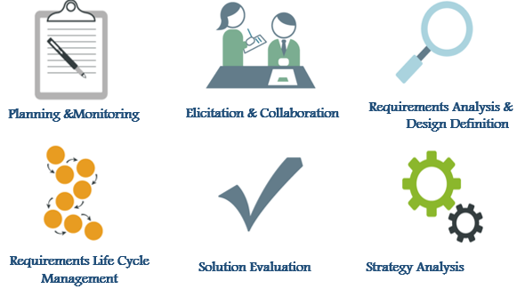

* **Business Analysis Planning and Monitoring**

This knowledge area covers the activities which a business analyst should follow to determine the efforts involved in the future steps. It mainly covers stakeholder analysis, managing risk, issues, and requirements. It also covers the techniques to manage the requirements and the track of the project progress.

* **Elicitation and Collaboration**

Requirements are the most important aspect of the project and understanding them correctly is of utmost importance. It’s not only important to gather the requirements from the available sources (sources may refer to stakeholders also) but also to elicit from them. There are several elicitation techniques followed by BA practitioners like brain storming, prototyping, interviewing etc to collect the most precise information and thus the ambiguity in the requirements can be mitigated. The actual purpose of the elicitation is to record the correct requirements of the stakeholders to avoid unwanted and superficial demands in future.

* **Requirements Analysis and Design Definition**

It covers the tasks that business analysts perform in order to manage and maintain requirements and design information from inception to retirement. These tasks describe establishing meaningful relationships between related requirements and designs and assessing, analyzing and gaining consensus on proposed changes to requirements and designs.

* **Requirements Life Cycle Management**:

It covers the tasks that business analysts perform in order to manage and maintain requirements and design information from inception to retirement. These tasks describe establishing meaningful relationships between related requirements and designs and assessing, analyzing and gaining consensus on proposed changes to requirements and designs.

* **Solution Evaluation**

This covers the assessment of the available solutions which can help the stakeholders select the most appropriate solution to implement the requirements. Once the best solution is selected the BA makes it sure that it meets those requirements throughout the lifecycle of the project.

* **Strategy analysis**

describes the business analysis work that must be performed to collaborate with stakeholders in order to identify a need of strategic or tactical importance (the business need), enable the enterprise to address that need, and align the resulting strategy for the change with higher- and lower-level strategies.

**Relationships Between Knowledge Areas**

The following diagram shows a general relationship between the knowledge areas.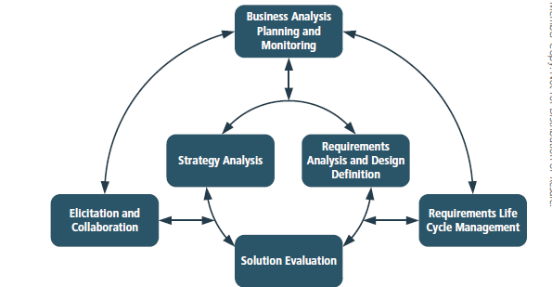

Business analysts perform tasks from all knowledge areas sequentially, iteratively, or simultaneously.